Checker Wars

Project Description Summary Final

**Group 16: Alex Choi, Andrew Macatangay, Sam Alammar, Luke Austin**  
CS 440  
University of Illinois Chicago

Checker Wars is a game that is developed with the user experience in mind. This style and mechanics of the game have been developed in such a way that they are intuitive and appealing and yet will not detract from the overall experience of play. The user interface and installation process are relatively pain-free and so the user of the product will focus solely on the product’s gameplay. Several refinements have been made such that all elements of the game will enhance and not hinder the player’s experience.

# Design

Though most computer games place a priority on speed over accuracy, accuracy is actually the most important part of the equation for an online strategy game like Checker Wars. Our design goals include both, but the goal emphasizes accuracy of recording and graphical representation

Below is the completed UML class diagram of the game detailing how all the pieces, players, and gameboard are connected together.

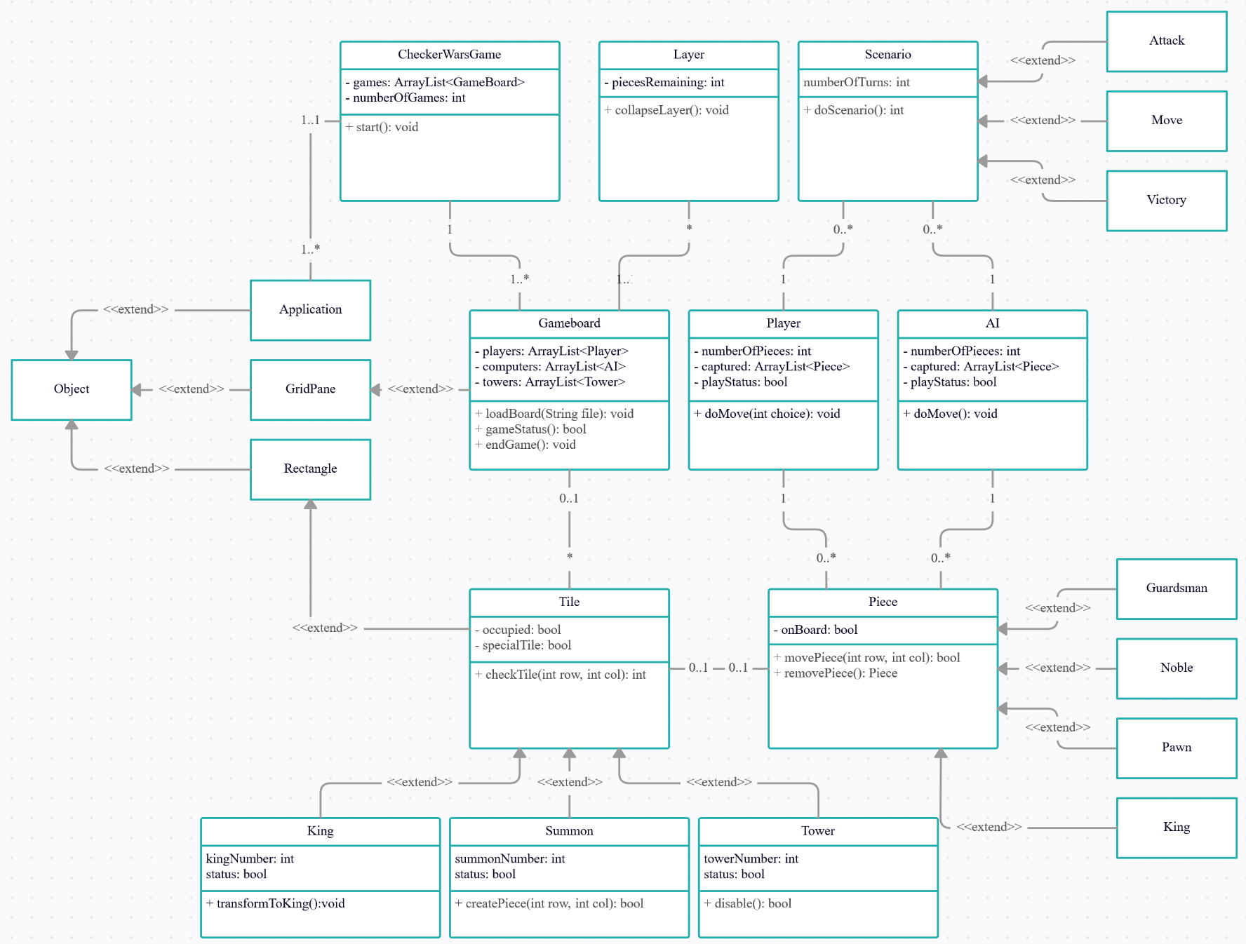

# Project Issues

When dealing with issues that we have had with our project, we took a bit more of a pragmatic approach. One of the main issues that we have discussed about involved the usage of user accounts and what that may entail. DRM being the main issue identified, as well as smaller security, legal, and user issues.

## Solutions

User account information protection or purchase information can be protected if the game is released on a Digital Rights Management (DRM) program. Since all DRMs require the user to register an account in order to utilize their game purchases, using a DRM would circumvent all of the previous issues with the user-account and most of the issues dealing with security and in-game purchases.

## New Problems

Currently, the problems we expect to run into are budgetary and planning/projection. Because this is the first game developed by Bohn Jell Entertainment, projections and expectations are at best an educated guest, and we will have to expect to pivot when needed. In terms of budget and budgeting, we are seriously considering hiring a personal accountant and a financial planner. Even with a conservative deadline with development, there will still be possible issues with distribution. Overall, we project that the majority of game purchases will be made digitally, however, for those wishing to purchase a physical copy, an entire distribution network will need to be sourced in order to get our product on store shelves.

## Risks

There were a multitude of risks we identified, all of which can be rectified either pre-emptively, or if the outcome of said risk isn’t too dire, we can wait until the event happens and fix it then. Some of these risks include: Lack of servers for influx of users, loss of funding, loss of staff, low quality server connections for gameplay, potential legal issues or unforeseen copyright issues, Language/translation issues, hacking, and logistical issues to name a few. For the full list please refer to the detailed final report.

## Costs

Based upon preliminary results and based upon average costs for independent video games our initial estimate for the total cost of development was $80,000 at the minimum to $160,000 at the higher end. We understand this is a low budget, but the game is developed by a small, tight-knit group of developers who have passion for the product and want to get it done quickly.

We estimated that the total time of development would be 2 months at the maximum which is a rather conservative estimate. If we break this estimate down further, we estimate that it would take roughly 3 weeks to work out the main game mechanics, an extra 2 weeks to deal with programming of user account systems and purchase systems, and the rest 3 weeks dealing with distribution, optimization, and general logistics such as advertising, hiring of new employees, and budgeting.